Specification of the AGATA triple cryostat

Phase 2

(13 September 2023)

**General**

The AGATA cryostat **(see Fig. 1)** will host three encapsulated, 36-fold segmented HPGe detectors of hexaconical, asymmetric shape **(see Fig 2).** The shapes of all three encapsulated detector types are different. The length of a detector capsule will be approx. 122mm (upper value), the diameter of the mounting lid approx. 85mm (upper value).The detectors have to be operated at LN2 temperature. All 111 electronic signals (3 x 36 segments and 3 cores) are used for high-resolution gamma spectroscopy and position determination of the interaction points of a gamma within the detectors.



**Fig. 1:** Drawing of an AGATA cryostat for three asymmetric, encapsulated HPGe-detectors with LN2-cooling. Warm preamplifiers are placed in the area between the tapered end-cap and the cables.

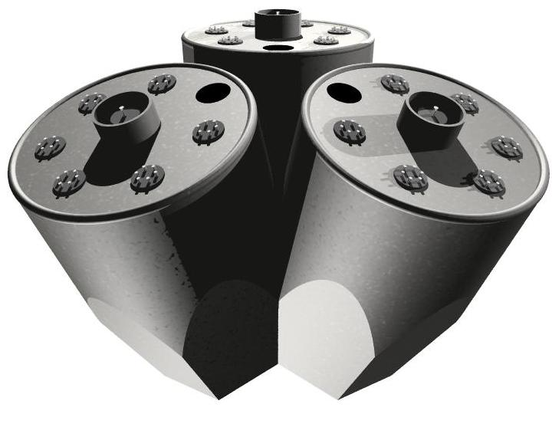

**Fig. 2:** Schematic diagram of the three, closely packed, asymmetric, encapsulated HPGe-detectors. This unit has to be operated in a cryostat at LN2-temperature.

A shell of 60 cryostats, each with 3 encapsulated detectors, will be the final set up for the AGATA 4π-array **(see Fig. 3)**.

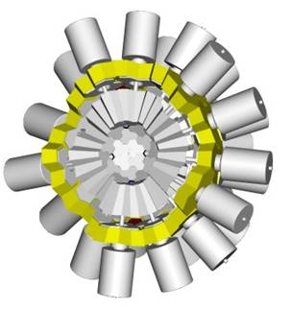

**Fig. 3:** A schematic diagram of one half of the 4π AGATA spectrometer comprising 60 cryostats, each with 3 encapsulated detectors.

**Technical Details for the Bidder**

1. **Specification list**

The cryostat will fulfil the following specifications:

- Thickness of the end cap in the region of the flat surfaces of the detectors: 1.0 mm.

- Thickness of the front face of the end cap: 1.5 mm.

- Material of end cap: AlMg3 or an Aluminum alloy with same physical properties to be discussed with the contractor.

- The end cap is split into a back ring and the front-end cap covering the detectors.

- Distance between the flat surfaces of the used detectors and the corresponding inner surface of the front-end cap: < 2.0 mm.

- Distance between adjacent flat surfaces of two detectors should be comprised between 0.2 mm and 0.5 mm (*remark 1*).

- The complete mechanical construction of the cryostat will fit in the free open angle, which is defined by the front region of the end cap with respect to the target position (see figures 1 and 3).

- The operating temperature of the detectors may not exceed 100K in any position at any

inclination angle of the detector axis. The temperature will be measured on the cooling finger close to the capsules.

- The cryostat must be provided with a capacity which read out will correspond to the LN2 filling level in the Dewar. If necessary, further details are available in the Nuclear Instrument and Method A 640 (2011) 133 paper *“The liquid nitrogen fill level meter for the AGATA triple cluster detector”* of D. Lersch et al.

- The holding time of the Dewar with powered electronics will be approx. 12 hours and not less than 10 hours.

- Two PT100 temperature resistors will be implemented – one on the cooling finger close to the capsules and one near the Dewar, to be confirmed with the contractor.

- The full specification of the AGATA preamplifiers and corresponding connectors are defined in the *AGATA preamplifier paper:* ‘AGATA Hybrid Preamplifiers with Pulser – Version 2.3 – March 2006’written by the AGATA preamplifier team and attached to this document.

- All electronics to be used for the first pre-amplifier stage of detector signal read outs (111 channels) will be placed inside the cold part of the cryostat in a position close to the capsules, to be confirmed with the contractor.

- Three independent motherboards will be used in each cryostat to operate the warm pre-amplifiers for each of the three capsules and will be equipped with AGATA triple segment pre-amplifiers and AGATA dual core pre-amplifiers with pulser, both being equipped with *Fischer* plugs (*remark 2*).

- The signal output cabling of all warm pre-amplifiers will be done as specified by the AGATA electronic group; in particular using housing mounted plugs 3M-MDR26 Camera Link (*remark 3*).

- The cryostat will be equipped with high voltage filters and standard SHV plugs.

- The resolution and cross-talk characteristics of each individual detectors will be tested by the AGATA detector test labs in the fully assembled ATC. Due to the higher density of electronics the energy resolution of each of the three core signals will be accepted even if they are slightly deteriorated as compared to the specification value of 2.35 keV at 1.33 MeV, with a maximum of +0.15 keV. The energy resolution of the segments must stay within the AGATA specifications of 1.30 keV at 60 keV for all segment signals with mean value 1.20 keV. Furthermore, cross talk picked up in the cryostat system must be < 0.1%.

- for what is not directly specified in this document one must refer to the *AGATA preamplifier paper* in attachment.

Remark 1: The AGATA collaboration has produced one set of 3 dummy capsules of the correct shape (IKP Uni Cologne) as a reference in agreement with the capsule drawings as defined in the AGATA collaboration publication in Figure 1 and 2 on p. 224 and 225 (Nuclear Instruments and Methods in Physics Research A 618 (2010) 223–233). These dummies are to the disposal of the cryostat manufacturer. The tolerances of mounting will be controlled with these dummies.

Remark 2: Possible warm pre-amplifiers for segment read out are: triple board GANIL or triple board MILANO; the AGATA detector team will define which one to be used taking care anyway to use around 50% of one type and 50% of the other type over a global cryostats production.

The warm pre-amplifier for core readout is: COLOGNE Dual Core type with pulser;

All warm pre-amplifiers must have one side equipped with Fisher connector and the other side with Micro Match connector.

The full specification of these preamplifiers and the connectors of the preamplifiers board are defined in the *AGATA preamplifier paper* attached to this document.

Remark 3: The complete network of electronic read out and control lines is defined by the AGATA electronic group in the *AGATA preamplifier paper* attached to this document.

This is accepted as basis of all connectors, motherboard layouts and read out cables.

1. **The AGATA triple cluster configuration**

- Dewar 4.5 l, with a capacitance read out depending on the filling level.

- Two PT100 for temperature control near the Dewar and close to the capsules.

- Split end cap with specified measurements and dimensions.

- Motherboards with *Fischer* plugs and D-Sub 9 power supply.

- 3 HV filter boxes with SHV plugs.

- electronics as for the *AGATA preamplifier paper*:

- Back lid housing with 21 plugs, type 3M-MDR26 and converter boards.

- Dual core preamp configuration, operation with pulser.

- 3 dual core boards, 36 triple segment boards (type to be defined for each contract).

- 18 segment preamp blocks to operate 108 cold preamplifiers.

- 3 core boards, cold FET and coupling capacitor.

- 3 signal feed through sections, titanium or equivalent, welded.

- high vacuum signal cable wires, 3 times 6 segments plus 1 core.

1. **Delivery**

Delivery time: 18 months, excepting eventual waiting time for the delivery of 3 operating capsules by the AGATA collaboration.

1. **Warranty**

Warranty: at least 2y for the cryostat including vacuum properties, cabling etc., excluding capsules which are delivered by the AGATA collaboration and warm preamplifiers which are defined by the AGATA collaboration.