

Watchers Online/Quasi-Online
User's Guide

AGATA Data Analysis Team

This document provides some informations to help an AGATA's user to work with the Watchers.

Contents
The GUI Interface 3
Basic things to be setup in case they are not. 7
Working at the Local level Processing 8
Working at the Global Level Processing 10
FAQS: feel free to complete this part 11
How to select the ADF files to be run 11
How to select the watchers applied to some ADF files 12

The GUI Interface
This section is related to the GUI interface used to play with the Watchers and the created spectra. The main window is a standard ROOT Browser Interface with some customization operated. Here is a snapshot of such a window:

On the left panel, there are three Folders.
- The first one name Tasks helps you to apply some actions on the Watchers. For instance one can Zero the spectra, Show some standard Canvases.
- The second Folder named GwWatchers contains all the Spectra that are produced by the Watchers at different levels.
- The third one contains the ROOT files opened if any (at present this option is used to monitor VAMOS spectra: ROOT Files ->OutVAMOS_Spectra.root)
On the right panel, the main window displays the spectra. Interaction with the interface is performed with the mouse, right buttons give access to some menus as shown here.

The Tasks folder is divided in sub-folders. In this example under Crystal_06 are attached two Watchers [RawSignal & TSRate] which spy the output of the CrystalProducer i.e. mainly the signal coming out from the 2 cores and 36 segments. In such a menu, a selection of one of the applies a method. Ex:
- Zero: reset all the spectra owned by the selected folder
- Snapshot: save in a ROOT file all the spectra owned by the selected folder
- ShowCanvas: Show some standard, useful spectra.
- SetActive: enable/disable the selected Watcher.
All Watchers have common actions [like Zero, Snapshot] but also some specifics. Some of them are explained in the following sections.
Spectra can be browsed as shown in the following snapshot. BaseLine_CoreX are 1D spectra while ADC is 2D one. Double click of any spectra to display it in the current pad/canvas.

If you need to create a new canvas to display some new spectra, you can use the Ctrl+C command or go to Browser->New Canvas.
If you would like to display more that one spectra, you can select in a Folder menu the Display or DisplaySum action as shown in the following snapshots. The first one gives the menu available when clicking on the right mouse button. Just select the one you want and you get a new panel which asks for several things [right up]. The standard options display all 1D spectra in the current pad. Here are some explanations concerning the different fields.
1 – the spectra you want to display with a filter on their name BaseLine* and on their type. {TH*} means any histogram in the ROOT world.
2 – the spectra you want to exclude with a filter on the name – and on the type {TH2*}. Here it means the 2D spectra are excluded.
3 – some option to display. clone means it displays clones of the selected histograms while wheel is used to set different colors while displaying a sum of histograms [DisplaySUM].
4 – it goest into the tree structure up to the given depth.

Be careful, there is no guess if there are enough pads in the output canvas to display all the selected histograms. You should do it by using the Divide method of any ROOT Canvas as shown in snapshot right, down.

There might be situations where many histograms are displayed in many pads and you cannot see them as you wish. Do deal with such situations, GammaWare provides a LoupeOnPad technics. In principle many Canvas opened in GammaWare/Watchers already provides this features. Put first the mouse in one Canvas and check by pressing the Space keyboard: you should have the current pad covered by a red cache and a new Canvas named LoupeOnPad opened as shown in the following picture.
Type h in the Canvas to get some help in the terminal. You can use the numerical keyboard (or if it works the keys with arrows) to navigate in the different canvases. If you are using the numeric keyboard, be sure the alpha numeric keyboard is activated. The pads you already loop on them stay in grey. To clean up those marking, just type the c keyboard.
If the feature is not there, just be sure the current canvas is the one you want to play with and in the command line ROOT session (Command tab in the right, bottom panel) just type.

RunLoupeOnPad()

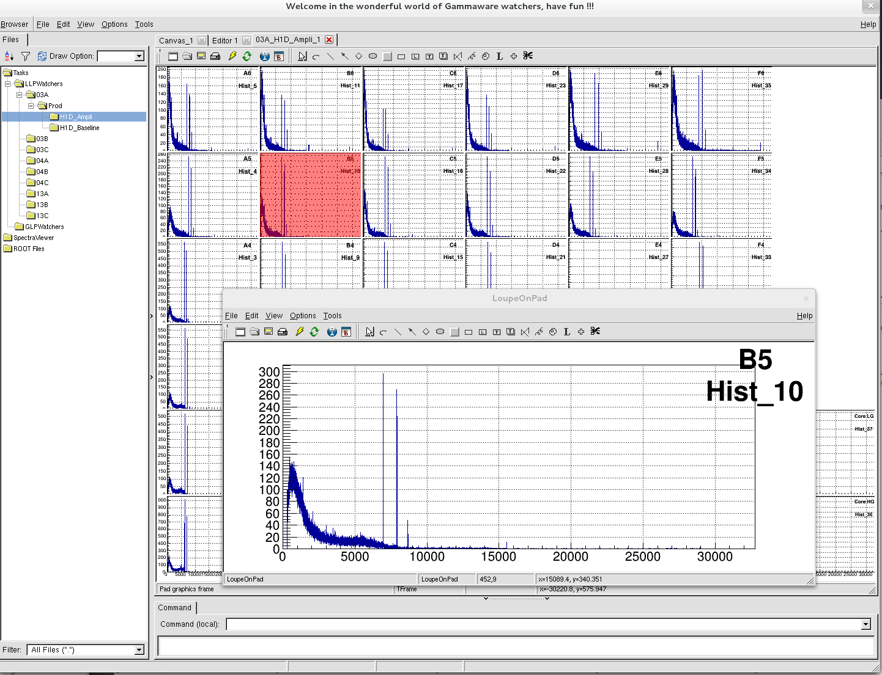

You may want to apply global actions on all the Watchers like for instance Zero and Save. This could be done using the menu of the Tasks/LoopControl. The Save method is explained in details here. In principle for online you should just be sure the autotime [field 4] is set to a reasonable time [given in s] like for instance 3600 to get an automatic snapshot of the spectra every hours.

Basic things to be setup in case they are not.

There are actions to be done at different levels depending whether you would like to check things are working properly. Spectra can be produced at the Local level and the Global level Processing. As well you may want to transform ADF files into ROOT Trees. To do that there are two analysis machines dedicated ana01 and ana02. To log in, do for one of the visu machine:
ssh -X analysis@ana01 or ssh -X analysis@ana02
It is better to have one session per task. To help you setting the environment to work, once you are on the analysis machine, do
source ./to_Workspace NAME_OF_THE_EXPERIMENT
where NAME_OF_THE_EXPERIMENT is the name of the experiment you would like to work on. In order to know the names of the last 5 experiments set, just do
./to_Workspace
This script set the environment and brings you to proper directory. If you would like to work with watchers, go to the OfficialWatcher one.

The following script /home/analysis/ShowEnv.sh gives you anytime the environment you are working in.

NOTES:
Looking at spectra/data, it might be you see something strange and you would like to see if it already happened or you would like to notify. To do this there is the elog. Here is the address at which you can find it if you have no web browser opened yet on it.
If you see anything wrong in the spectra, please write it in the log book
http://run-control.agata.daq:8989/

There is a forum you can have a look at if you have any problem there might be a solution already posted thee. Do not hesitate also to post new tickets in case of new topics.
https://forum.gsi.de/
[AGATA subsection and then the subject you are concerned it]

Working at the Local level Processing

“Online Quality Check of the AGATA/GANIL Data at the Local Level Processing”

The goal is to check the signals coming out of the crystals and the way they are treated up to the PSA as well as the data coming from the GANIL world into the AGATA world.

- Start the Online Watchers
root -l SpyLLP.C
It starts the spying at the different local levels.

- Basic checks

After starting the LLP Watchers, there is a way to open several windows which contain the very basic spectra to be check regularly during an experiment. To do this, go to the Tools Folder in the GUI and select the StartManipViewLLP as depicted in the following picture. It gives the rates [based on the timestamp variable] at different levels, the Core energies of the different crystals and matrices giving the energies extracted from the signals for cores and segments.

Here are some snapshots you are likely to see after this action:
The TS distributions giving the rates of the different crystals. Because at this level the data are spied, there may be holes in the distributions corresponding to the latency of the full system to retrieve from the DAQ a buffer of adf data.
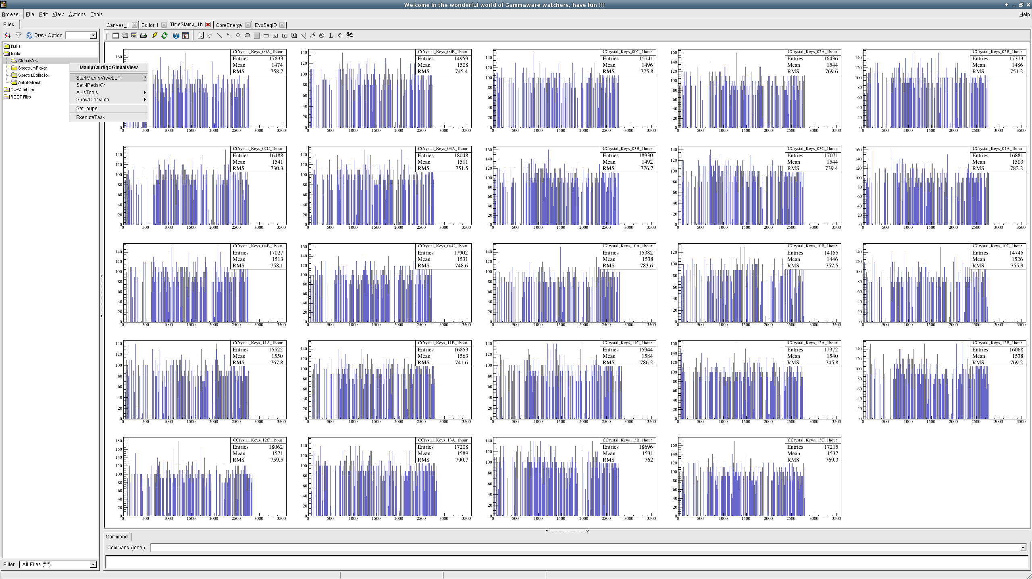
The core energies of the different crystals
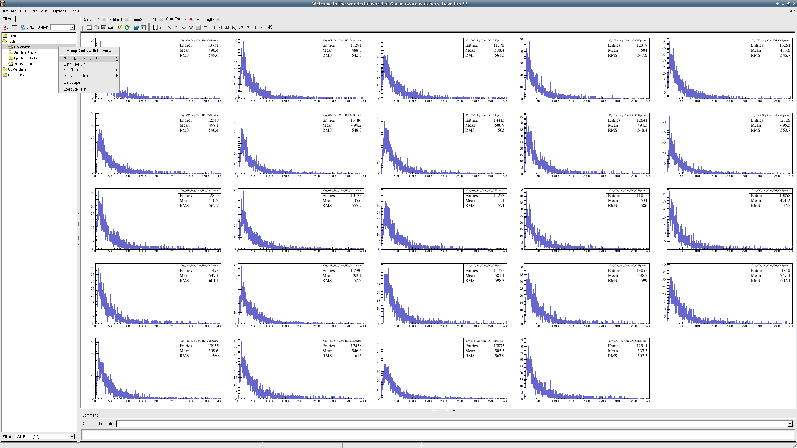
and a more detailed view showing the cores/segments amplitudes.

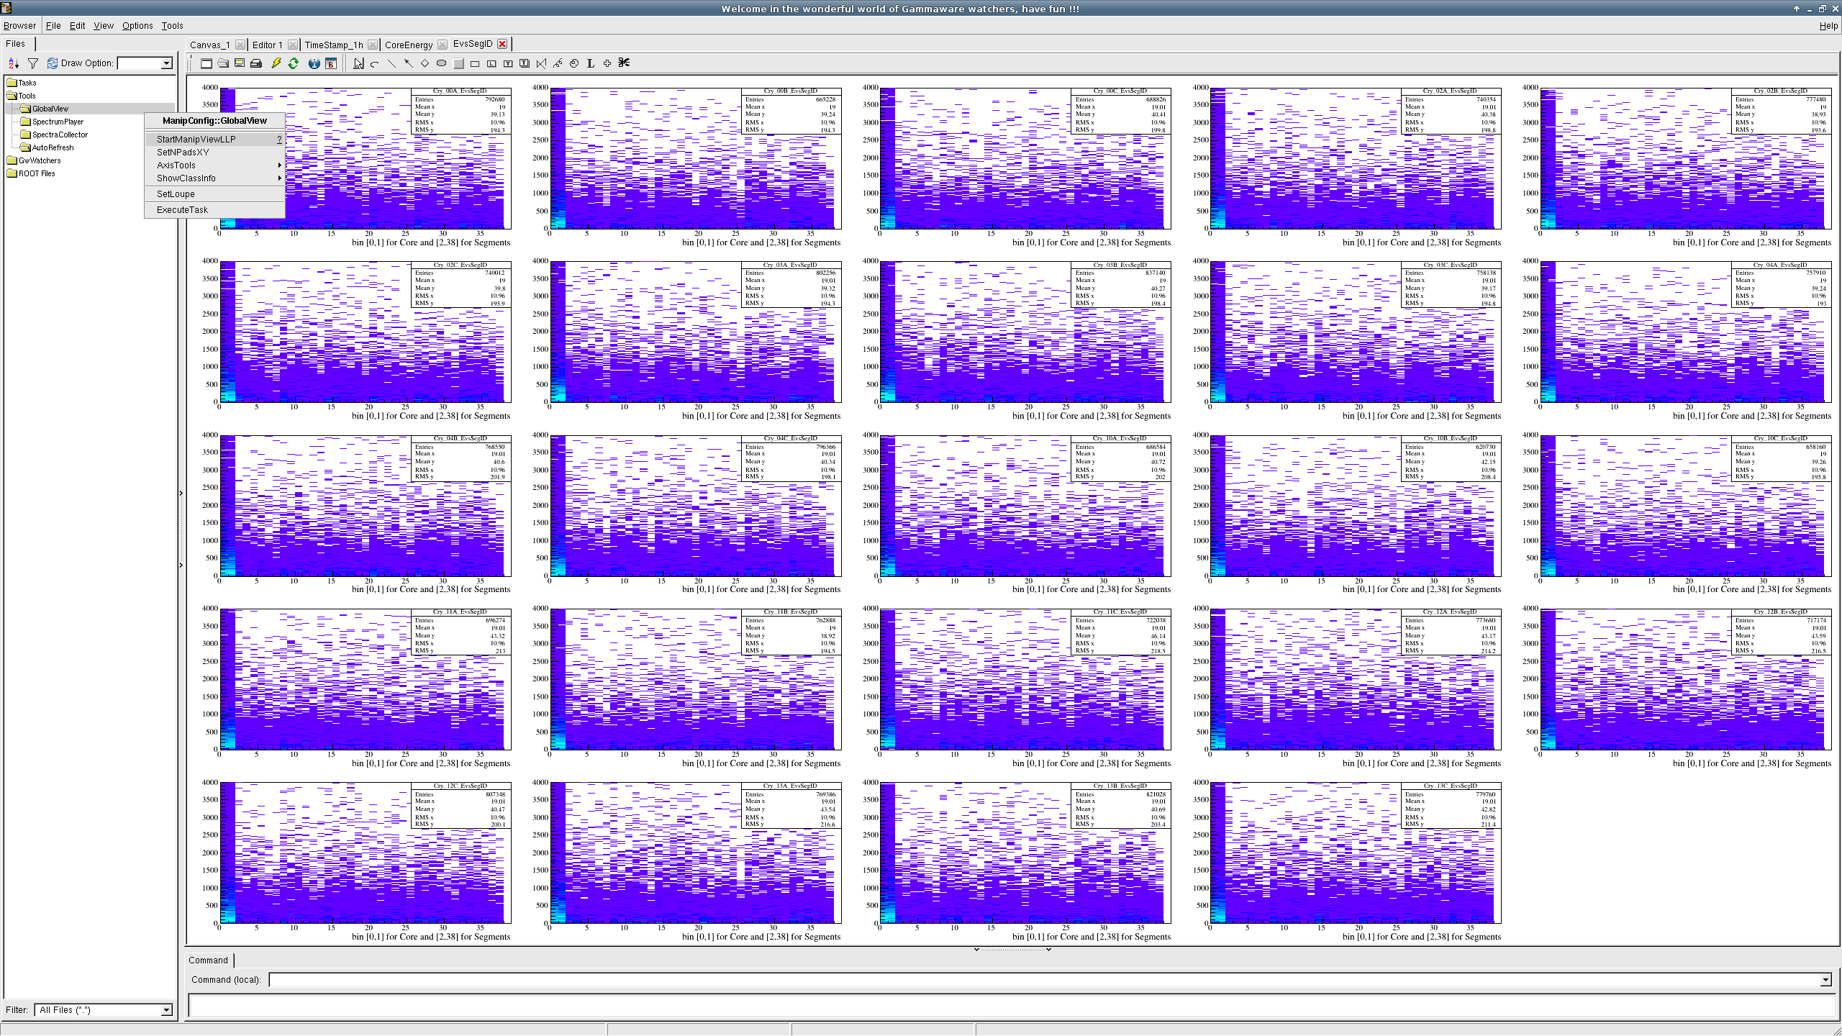
- More precise checks for the different levels

  - Raw and Calibrated Signals

For any crystal, the baseline distribution could be obtained From RawSignalsXX or CalibSignalsXX using the different methods. There are different options available: none, sig, amp and base. With those canvases you can check many different aspects.
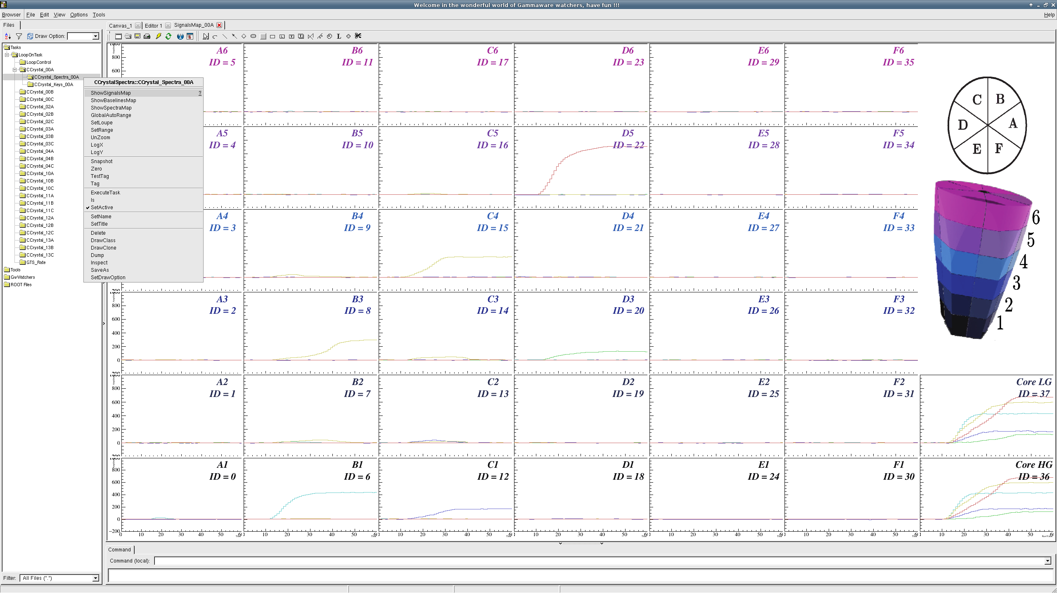
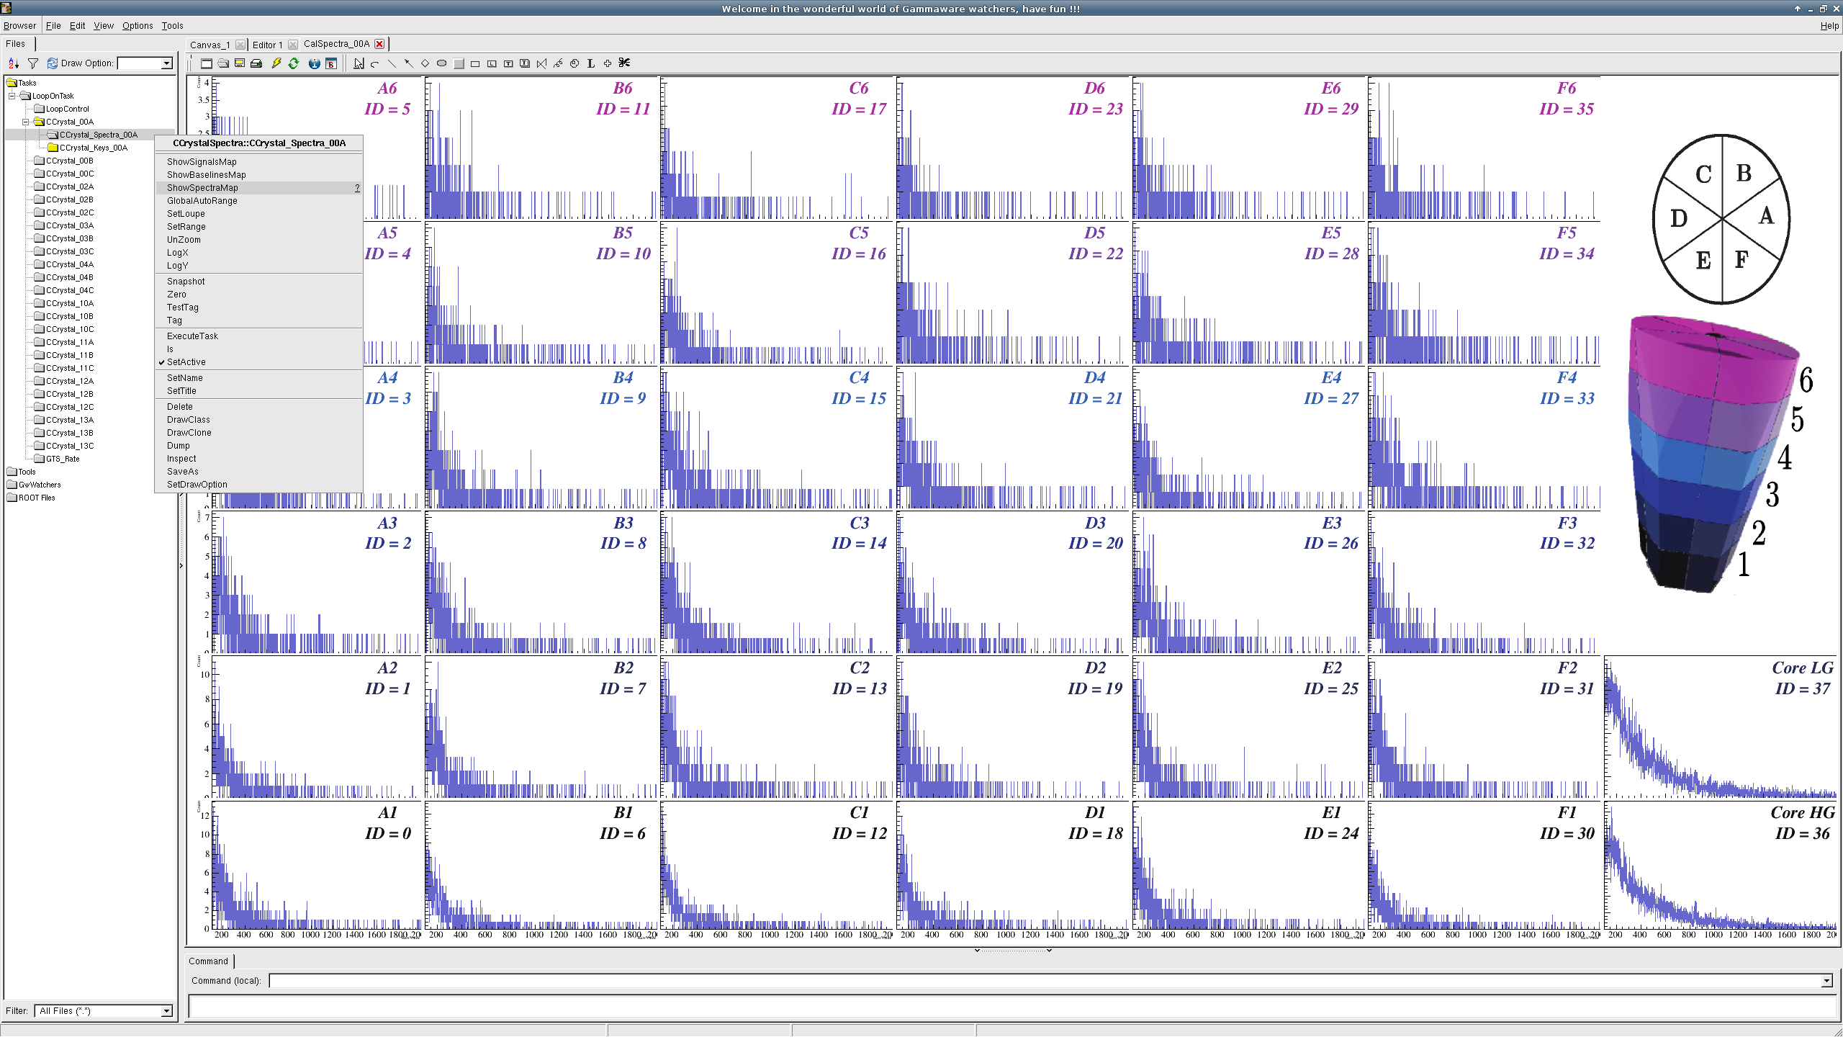
As seen, the panels are really explicit, showing a picture of a crystal to get an idea of what represents a given histogram.

  - Hits Produced by the PSA algorithm.

There are different spectra produced by the Watchers out of the PSA. They can be checked in the PSA_ folders, the most important one is PSAHits. With the ShowXXXX methods you will get the most significant spectra.
Here for one crystal the spectra of the different energies [core ½, sum of segments] together with the number of hits distribution.

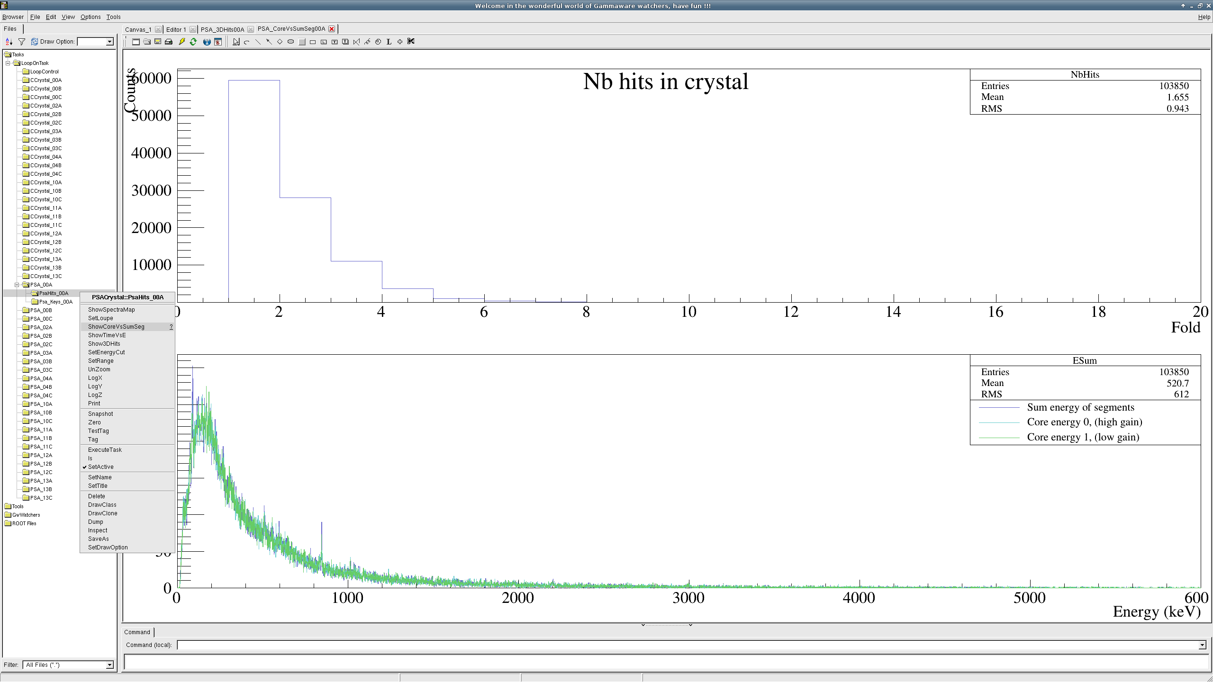
As well, one may have a look at the hits in a 3D space. Once you have it you can slice it with the traditional root tools. As well, the Watcher, with the SetEnergyCut method allows to select only the hit distribution corresponding to an energy range on the core.

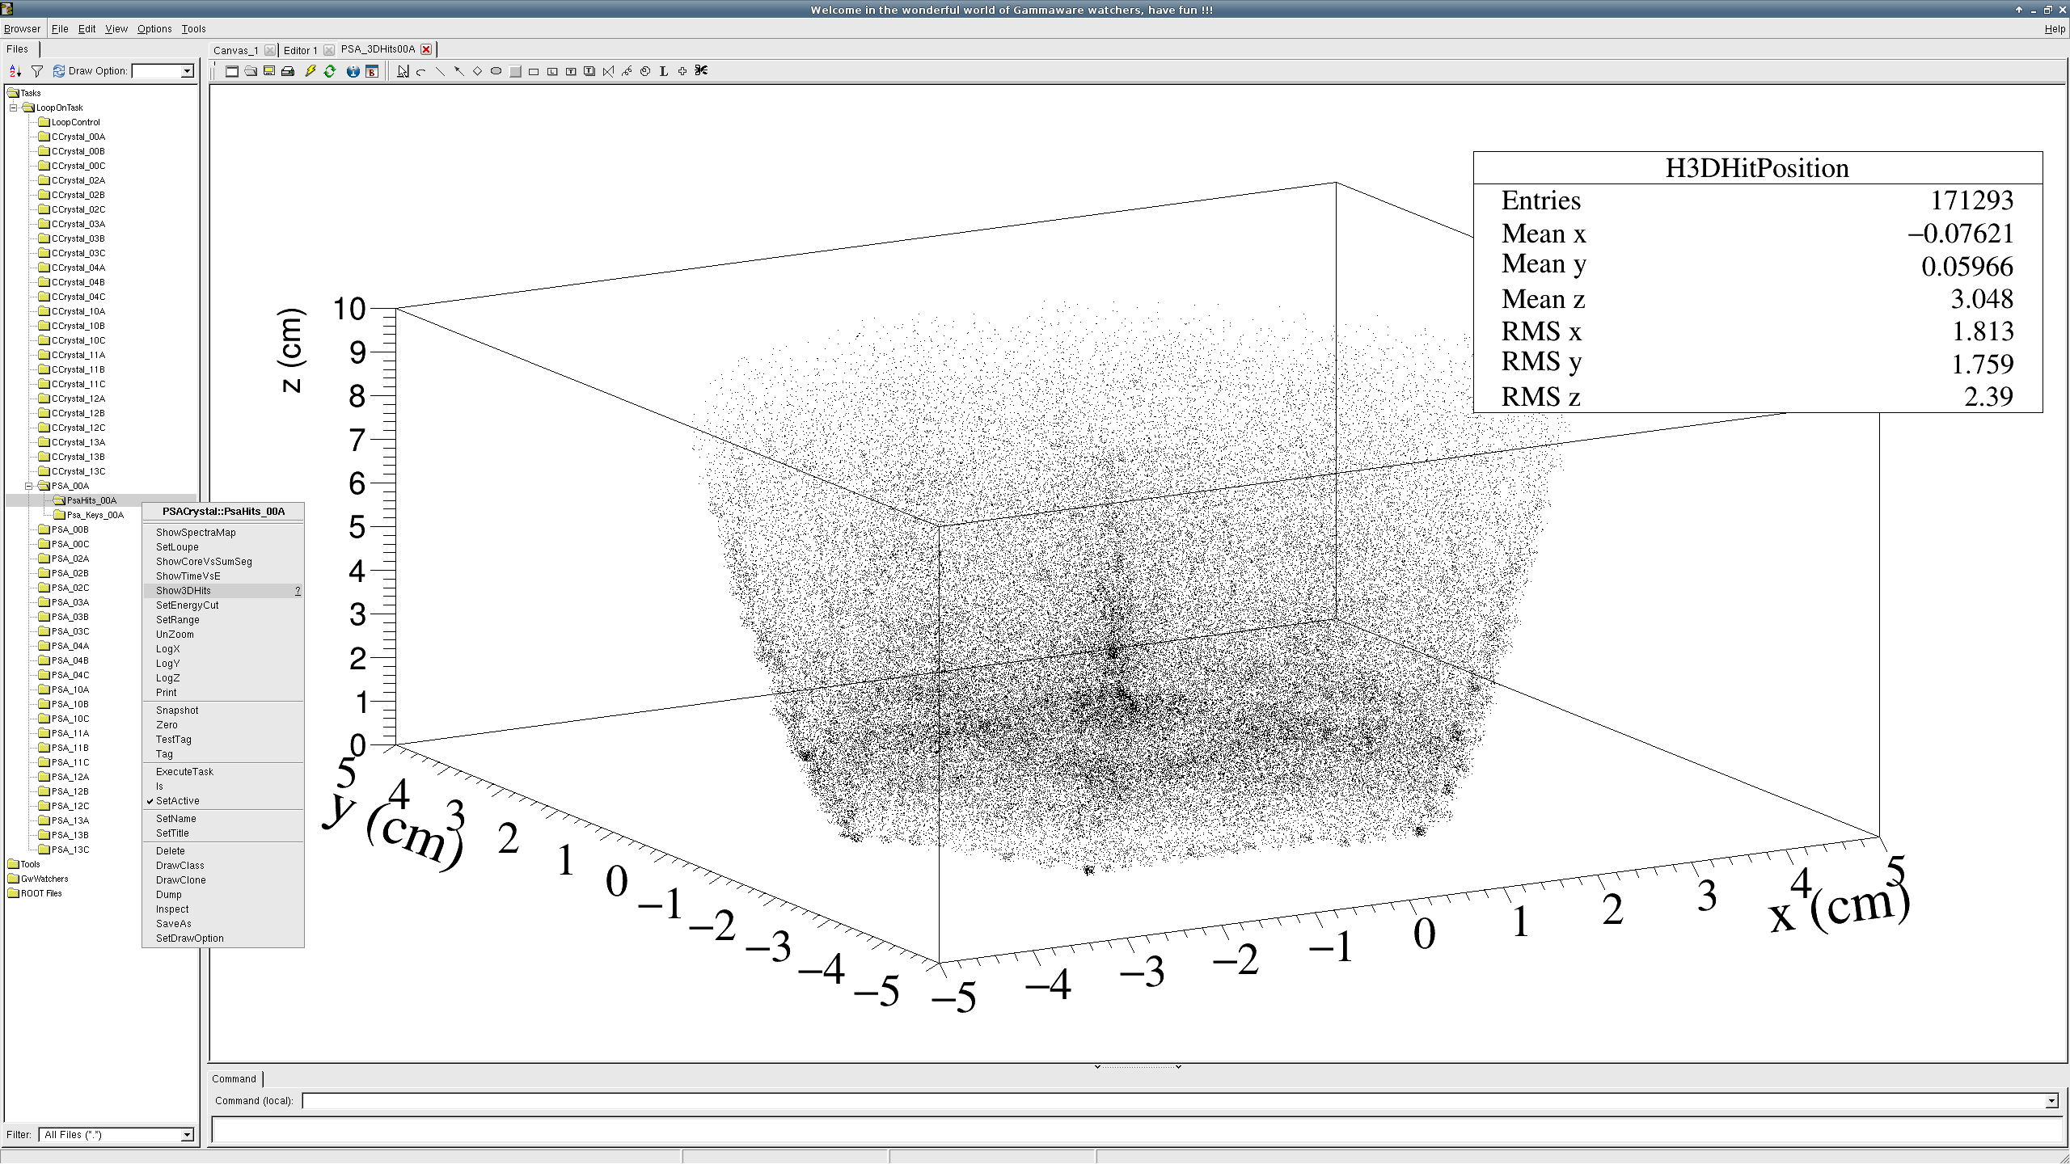

  - Raw Data Produced by the Ancillary

The data are collected at different levels. The buffer of raw data are decoded, using the MFM library, to provide basics checks. This is done by the Watcher Called MFMWatcher. The most important histogram produced is a matrix [right, bottom pad in the following picture] with on the Y axis the Value Content for all the Labels given on the X axis.

Another way is to look at the spectra produced by the VAMOS library. They are available under the ROOT file [temporarily] named Out/VAMOS_Spectra.root [see following picture]. Those spectra can be found also in different VAMOS visu.

“Running Quasi-online/Offline the Watchers on PSA files / VAMOS files”

– to be written

“Using GammaWare to calibrate AGATA with the Spectra produced in actors [tkt alternative]”

AGATA actors processing the data flow produce histograms that can be written into files. They are read usually using the tkt viewer. They are also browsable into the GammaWare. To do this:

- Start the ShowAsTkT.C macro
root -l ShowAsTkT.C
It starts everything. You are asked to select a file which should be the gen_conf.py in one of the run directory. It lunches automatically all the spectra. There are accessible in the SpectraViewer folder. As well there several methods to fill / Calibrate.

– to be completed

Working at the Global Level Processing

“Online Quality Check of the AGATA/VAMOS Data at the Global Level Processing”

The goal is to check the Quality of the Data at the Global Level Processing i.e. after the AGATA event builder, the AGATA Merger and the Tracking algorithm.

- Start the Online Watchers
root -l SpyGLP.C
It starts the spying at the global level.

– to be written

Working offline to convert ADF files into ROOT Trees

The Watchers can produced Spectra directly from ADF data but provide also a way to convert those files into ROOT TTREE. The conversion is made run by run so that at the end there is one ROOT file for each run. Here is the simpliest way to do this through a bash script called :
./StartBatch.sh 31 or ./StartBatch.sh 30 40
Here is a snapshot of the content of the script you have to change the content to convert the data you would like:

#!/bin/bash
# Set environement

Exp="/agatadisks/e669/e669/Replay"
ADFData="Out/Merger"
RunPatern="run_"
Filter="*.adf"
OutDir="./Out"

if [ $# == 0 ]; then
echo "Usage $0 <RunNr> "
echo " Error : <RunNr> not specified"
exit 1
fi

if [ $# -gt 1 ]; then
echo "Analysing range run $1 -- $2"
start=$1
end=$2
else
echo "Analysing run $1 -- $#"
start=$1
end=$1
fi

echo "Analysing run $start to $end"

for ((RunNr=$start; RunNr<=$end; RunNr++))
do
echo "Converting $RunNr --> $OutDir"
root -q -b "RunADFToTree.C($RunNr,\"$Exp\",\"$ADFData\",\"$RunPatern\",\"$Filter\",\"$OutDir\")"
done

The fields in color are to be adapted to you needs. In this example you require the conversion of
any adf files (*.adf)
available in the replay directory of the e669 experiment:
/agatadisks/e669/e669/Replay/run_0038/Out/Merger/
and you would like to have the output trees in
./Out

FAQS: feel free to complete this part

How to play with ROOT Trees
To get the sum spectra

How to select the ADF files to be run
There are different ways.
The first one is to edit the RootAFP.conf file and give the list of files you would like to run on. Here is a snapshot of such a file which select two files produced out of the tracking for run 0073.

#l /agatadisks/eagata/158er_commissioning/run_0073.dat.15nov.14_01h10m44s/Data/04C/psa_0000.adf
l /agatadisks/eagata/158er_commissioning/run_0073.dat.15nov.14_01h10m44s/Data/Global/Tracked_0000.adf
l /agatadisks/eagata/158er_commissioning/run_0073.dat.15nov.14_01h10m44s/Data/Global/Tracked_0001.adf

then
root -l GANILLoadWatchers.C
root[0] .L OfflineWatchers.C+
root[1] OfflineWatchers()

The second way is to prepare a file with a different name that RootAFP.conf [here MyAFP.conf] and run the following
root -l GANILLoadWatchers.C
root[0] .L OfflineWatchers.C+
root[1] OfflineWatchers(“MyAFP.conf”)

The third way consists in asking for files by giving the run number. For that the path to the experiment, the path to the adf files under the run number as well as a possible pattern for adf files are asked. Ex:
root -l GANILLoadWatchers.C
root[0] .L OfflineWatchers.C+
root[1] OfflineWatchers(73,”/agatadisks/eagata/158er_commissioning/”,Data/Global/,”*.adf”)

How to select the watchers applied to some ADF files
In the Watcher directory there are all the official Watchers used to check Online the Quality of the data. You may need to add/remove some of them and apply them on Data Written in ADF files.
To do this, copy some files you are to work with in a sub-directory [called MyDir here]:
mkdir MyDir
cp SetupWatchers.C MyDir/SetupWatchers.C
cp OfflineWatchers.C MyDir/OfflineWatchers.C
Edit MyDir/Offlinewatcher.C and change the text in red according to your needs [here on Tracked files]
// same include that for Online
#include "SetupWatchers.C"

//! This is the part the user should adapt to his needs
namespace {
TString EntryPointInSetupWatchers = "ADF"; // selection in the SetupWatcher.C file
….
into
// same include that for Online
#include "MyDir/SetupWatchers.C"

//! This is the part the user should adapt to his needs
namespace {
TString EntryPointInSetupWatchers = "TRACKING"; // selection in the MySetupWatcher.C file
….

Edit MyDir/SetupWatchers.C and add/remove the watcher you want
// TRACKING Level //
if ( DFtype.Contains("TRACKING") ) {

// a trigger on event with hits, tracked gammas and ancillary
AgataFrameTrigger *trig =
AgataFrameTrigger::Build("TRACKING", "event:data event:data:psa data:tracked data:ranc0");
// set the main trigger to coincidences between ancillary et gammas
fd->SetTrigger(trig);

// specific to tracked frame
// gamma-gamma matrix
fd->Add<Coinc2D>(GetWN("GxG",ext),"Gamma Gamma coincidence");
// fd->Add<EveTrack>(GetWN("Eve",ext),"Gamma Gamma coincidence");
fd->Add<HitsSpectra>(GetWN("HitsSpectra",ext),"Gamma-ray spectra from Hits");
….
then
root -l GANILLoadWatchers.C
root[0] .L MyDir/OfflineWatchers.C+
root[1] OfflineWatchers()

