  Phase 2 |  | Working  document  #0

Data Processing, Re-processing,
Management and Analysis
Part 3
A roadmap for Phase2
The Data Processing Team

Version / Date | Comments | ATRIUM Link
1 - 02/02/2022 | First version | none

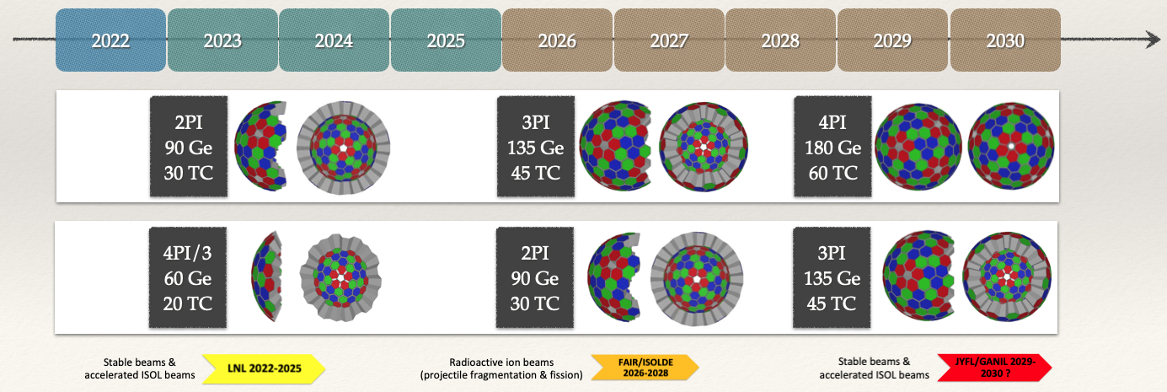
Table of Contents
Introduction 3
Chapter 1 - Phase 2 electronic & ancillaries integration 4
Period 2022-25 : phase 1 & phase 2 electronic + LNL ancillaries 4
AGATA Phase2 electronic integration in the DAQ box 4
STARE to computer node 4
DAQ box : hardware architecture 7
DAQ box : software architecture 8
Period 2026-30 : phase 2 electronic + GSI ancillaries 12
AGATA Phase2 electronic integration in the DAQ box 12
DAQ box : hardware architecture 12
DAQ box : software architecture 12
Chapter 2 - Data Management 13
Chapter 3 - Advanced data pipelines and workflows 14
Chapter 4 – Data Analysis & Re Processing 15

Introduction
The goal of this document is to draw some directions of developments to try and reach the main objectives of the Phase 2 proposal. The different tasks don’t have all the same timescale.
One of the first main tasks is to deal with the new AGATA electronic : it is treated in the first chapter of this document. The new electronic is supposed to substitute the old ones progressively with the objectives to have only in the array phase 2 electronic by 2025. During this phase 2, as usual for AGATA, it is also required to interface the array with all the ancillaries to be used during the different campaigns.
The data processing model (see document part 1&2) online but also offline should evolve to :
- be able to deal with 180 capsules in the array at high counting rates (up to 50kHz)
  - means more reliable data processing/analysis & more automatic data quality checks
- include improved PSA or Tracking algorithms
  - with as a basis AGS for PSA and current OFT Tracking
  - with new algorithms possibly including Machine Learning approaches
- prepare open data, open science requirements
  - make it easier to save data, download them, run on various environments
  - exchange re-processed data
- manage more complex topologies
  - software trigger should be possible at different levels (in particular at the global level) of the processing chain
  - add processes running on heterogenous materials

This requires to develop new data pipelines with the requirement to :
- not break the current system
- allow to run as much as possible the same tools in both online and offline environments
- allow as much as possible 'easy' re-processing on single computers, clusters or clouds

The second chapter details the developments to deal with open data, the third one is connected to complex topologies and the fourth one is dedicated to advanced data analysis.

Chapter 1 - Phase 2 electronic & ancillaries integration
This chapter is divided in two parts since the phase 2 electronic is supposed to be integrated progressively in the array. During a first stage (2022-2025), this new electronic is to be used together with the phase 1 electronic [GGP]. After this stage, the AGATA array is going to be fully equipped with phase 2 electronics.
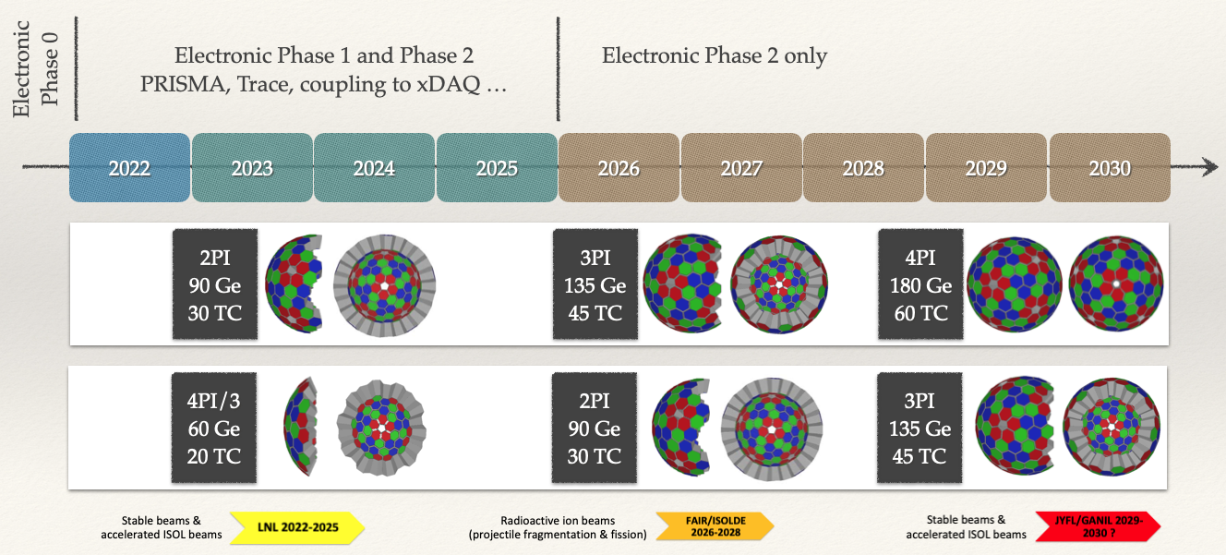Figure 1: Phase 2 electronics milestones. Two scenarios of evolution for the full array are given. XDAQ is the local DAQ system at Legnaro, it should manage directly the ancillaries.

Period 2022-25 : phase 1 & phase 2 electronic + LNL ancillaries

AGATA Phase2 electronic integration in the DAQ box

STARE to computer node – UDP Datagram Protocol
The phase 2 electronics is based on a new board which communicates with computers through standards-based networkings. The signals out of one capsule are digitized, processed and sent through 10Gbits/s links using the UDP protocol as illustrated in the Figure 2.

The current (phase 1) signals are sampled at 100Mhz and for each digitized trace 100 samples are transport out of the electronic cards : this requires within the current ADF format 8088 bytes per event due to additional parameters such as the energy given by the Moving Window Deconvolution (MWD) algorithm performed inside the FPGA. Under the assumption that an event could be coded with less that 8192 bytes, Figure 2 gives some constraints on the data pipeline to be built.

On the computer side, one process is required to absorb the UDP flux and to prepare data to be move to the data processing (DCOD) environment. This stage has been called SQM for STARE Queue Manager. Several issues are to be well mastered :
- because of the high rates and the UDP protocol, losses of UDP packets should be checked
- the computer memory could be quickly filled with events which have to be consumed !

In case of critical situation (important lost of UDP packet or computer memory saturated), the system should be regulated or stopped. For any action, the new electronic board is controlled using the high performance control bus IPbus.
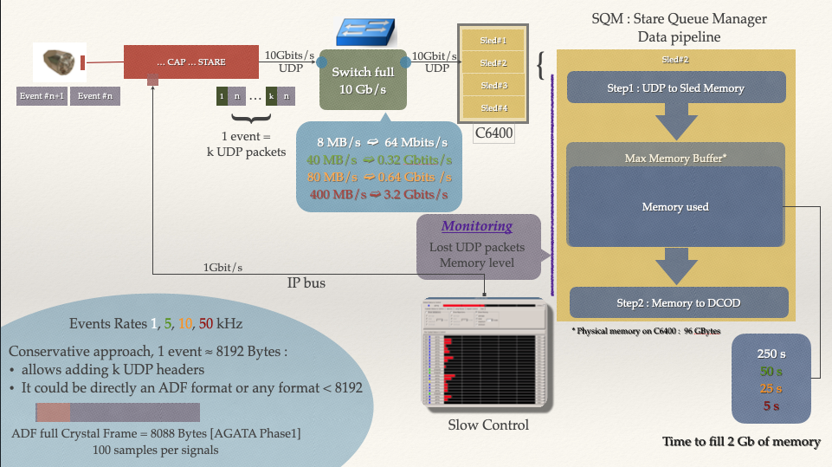Figure 2: Data pipeline from STARE to Computer Memory. C6400 nodes are composed of 4 independent slots (sleds) having each 48 cores (2Xeon Silver 4214R@2.4GHz) and 92Go RAM

Note about the PACE board see also https://arxiv.org/ftp/arxiv/papers/2011/2011.06092.pdf

Here is a diagram of the PACE-CAP firmware map from the digitizer to the STARE board.
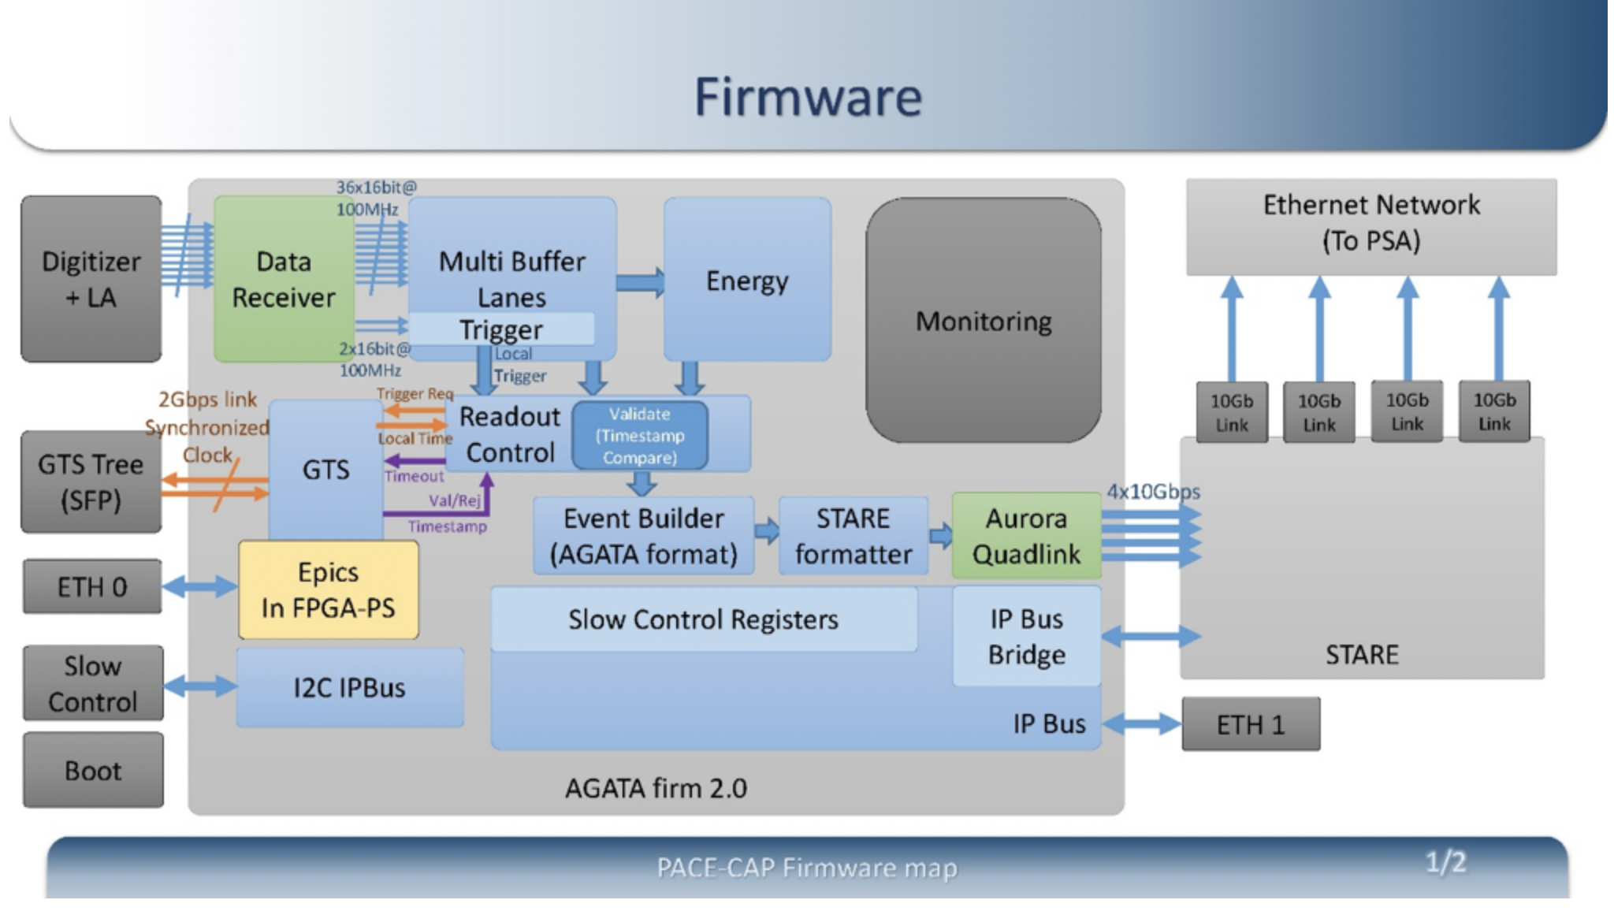Figure 3: PACE-CAP firmware map
The STARE board is the last stage in charge of sending data to ethernet via four 10Gb/s links. In principle the four links could be used which allow a maximum of data transferred up to 40 Gbits/s : this depends on the logic in the STARE formatter (and/of the event builder). Assuming a maximum of 50 kHz and 8kBytes per event, a single link should be enough (at least for the period where the two electronics GGP and PACE are to be used at the same time). Other links could be used for monitoring. In this case it is foreseen to send long traces which breaks the limit of 8kBytes for a full event. The possibility, to not break 8kBytes per event, could be to send only one or few channels at the same time : indeed monitoring does not required to have all the channels in coincidence.

As Ethernet frame, UDP follows the Maximum Transmission Unit (MTU) of the local network which is 1500 bytes of payload for a standard network : a 8kBytes frame in such a case is necessary sent using several UDP packets. A solution could be to configure the network to deal with jumbo frames which allow up to 9000 bytes of payload. However, one has to be sure each link in the path (switches, routers, computers) is able to deal with such a non standard format otherwise performances may decrease since incompatible devices may drop frames or fragment them. In case a full event is fragmented into several UDP packets at the STARE level, the lost of one of them is enough to loose the full event. On the other hand, relying on jumbo frames may increased the rate of lost of a single UDP packet from STARE to the computer but dealing with losses is much more simple: tests are required to determined what is the optimal configuration.

Since SQM pushes data into memory (foreseen is to used a circular buffer) there is a strong constraint also between SQM and the process in charge of consuming the data in memory buffers by sending them to the data pipelines : indeed one has to be sure frames have not been lost. At each level one has then to benchmark the performances in term of data rates sustained and losses of frames. Of course tests should also be realized in realistic environments i.e. in case many queues are in the system to deal with more that one crystal. This could be realized in a first step by having a STARE emulator i.e. a UDP server sending ADF frames (read from ADF files) the same way it is to be done by STARE. Thus series of tests could be drawn : with standard networks or jumbo frame networks, from one STARE (emulated and then real data) to one computer, from emulated STARE like data up to the memory consumer (one data pipeline then many).

Here is a non exhaustive roadmap for SQM developments.

- Using standard network
  - On emulated data from the STARE board (1032 bytes/UDP, 1024 for payload+8 header)
    - Check maximum transfer rates from STARE to a close computer node (C6400)
      - Rates ≥ 3.2 Gbits/s obtained without any losses : DONE
Up to 7.5 Gbits/s obtained without losses. It has required optimizations on the computer for the highest rates. For instance the memory used to push UDP packet should be the one attached the CPU on which the process is running. Rates ≥ 3.2 Gbits/s reached also going through a 10Gbits/s switch.
      - Check transfer rates from 2 STARE and a ‘close’ (same room) computer
      - Check transfer rates form STARE to a ‘distance’ computer node (through routers)
  - On real data from the STARE board
  - On emulated data from a computer
    - Emulator reading ADF files and sending ‘STARE data like’ through UDP port
      - first version available … up to 2.5 Gbits/s emulated so far, improvement foreseen
    - Check transfer rates from one computer to one computer node (C6400)
      - Check transfer rates between one emulator and one SQM
      - Start development of the actor in charge of memory consumption
      - Tests with many emulators filling many queues
      - Check integrity of the ADF flow once in DCOD
- Using networks able to deal with Jumbo Frames
  - To be discussed whether or not we should make the test ?
  - On emulated data from a computer
  - On emulated data from the STARE board
- Connection with Topology Manager
  - see Topology Manager
- Connection with Slow Control GUI
  - see Slow Control
- Check the validity of the ADF flow once in DCOD

STARE to computer node – RUDP Datagram Protocol
As a Connectionless Protocol, UDP transfers data without even to be sure the receiver is available to get the data. It allows potentially to transfer at extremely high rates (compared for instance to TCP) but the cost to pay is UDP packets may be lost and may also arrive unordered relative to their emission. On top on UDP one can build Reliable UDP transfer Protocol to still keep as much as possible high transfer rates but at the same time ensure the quality of the data stream is under some control (guaranteed arrival, order delivery, eventually without errors) .
Figure 4 shows how an event is transported from the CAP level up to the computer level through STARE+SQM.
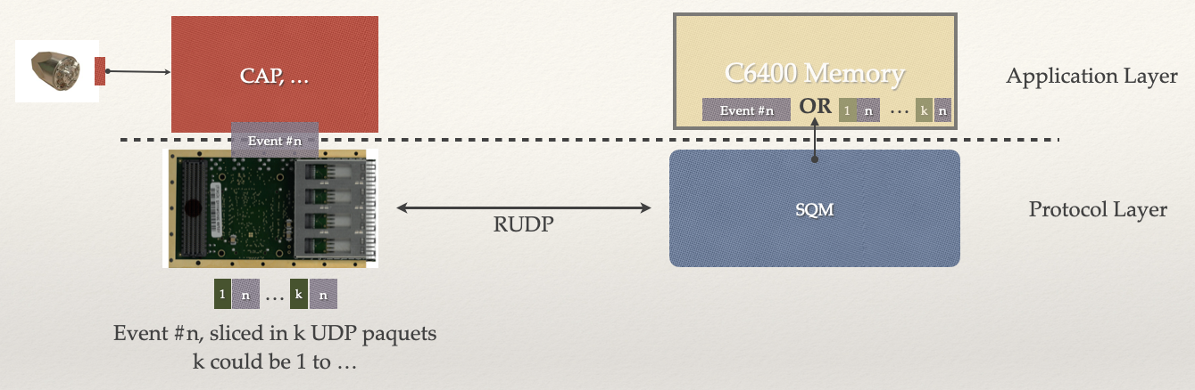Figure 4: RUDP between STARE and SQM
As for just UDP, a full event, sliced (or not in case k=1) in k packets, is sent through the network to a computer. The main difference of RUDP, compared to using only UDP, is a communication protocol should be set between STARE and SQM (arrow in both direction) so that SQM is able to deliver to the application layer (memory) full events (as a single packet or an already ordered list eventually without the additional UDP header) ordered in time. Such RUDP protocol relies strongly on acknowledgements sent from the receiver to the sender.
The RUPD foreseen for STARE is based on Sliding Window Protocol. Amongst three of them, it is the Selective Repeat Protocol which has been selected for the STARE board. See for instance https://citeseerx.ist.psu.edu/viewdoc/download?doi=10.1.1.831.3872&rep=rep1&type=pdf.
The mechanism is illustrated in Figure 5
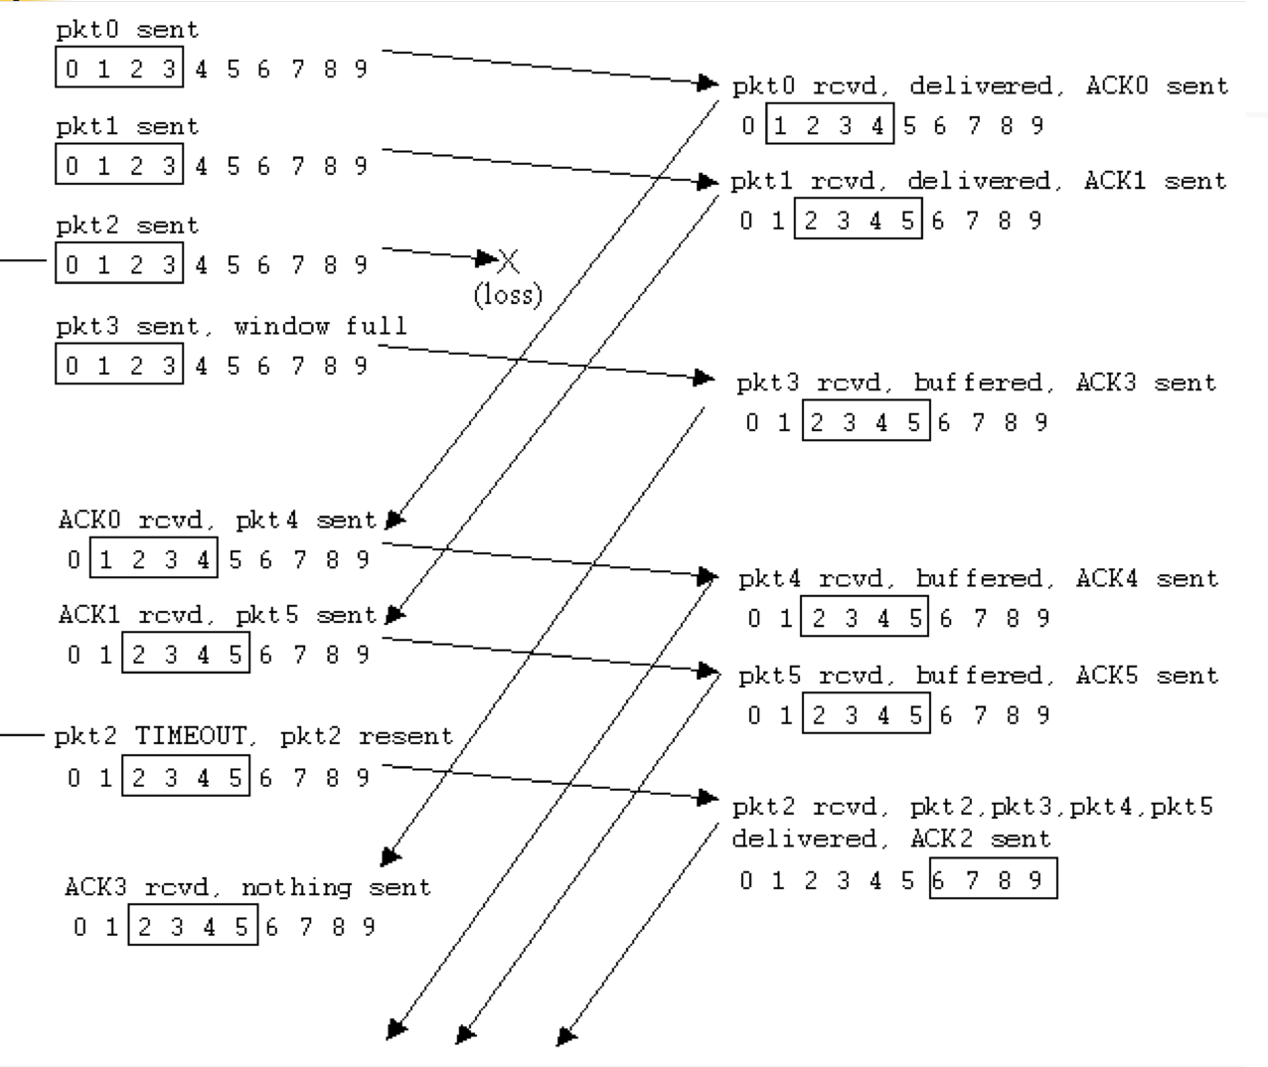Figure 5: Selective Repeat Protocol https://www.cs.rochester.edu/~kshen/csc257-fall2007/lectures/lecture11-rdt.pdf

Both the sender and the receiver manage a sliding window (surrounded by a rectangle, 4 UDP packets here). At the beginning, the sender sent the labelled (counters) packets of the window one by one, ordered, without waiting for any answer. Once the receiver got the next expected packet, it sent back to the receiver the corresponding acknowledgement. The receiver keeps all the packets in the window alive until all acknowledgements have been received. There is a timer attached to a window so that if after the given time all the acknowledgements have not been received, the missing acknowledged packets are resent. On the receiver side, the packets are buffered and once what is required by the application layer is there it should be pushed toward it.
Here is a non exhaustive roadmap for SQM developments, RUDP based.

- Protocol between STARE and SQM
  - The exact protocol (format of the messages) should be established
    - this is a blocking point for the rest of the actions
  - Implementation in SQM and in the STARE Emulator
    - test with the emulator
    - test with STARE
- About same tests that raw UDP for the final performances and integration in a DCOD flow

Notes:
- Thanks to the RUDP, the data stream out of SQM should be what is emitted by STARE ordered and without any losses. To further check the quality of the data checksum might be added. It has to be done both on the sender and receiver side, probably at the cost of time required to compute it !
- Because of these additional checks Figure 2 is modified as shown in Figure 6 and the monitoring of losses packet in not required anymore.

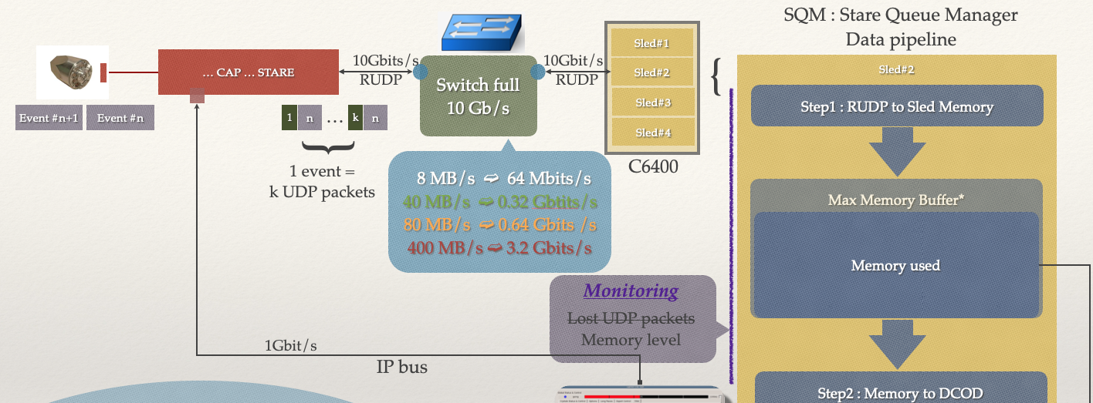Figure 6: Modification of Figure 2 taking into account RUDP

DAQ box : hardware architecture
At the global level, the DAQ box should be designed to integrate at the same time, at least at the beginning of the AGATA phase 2, the GGP – phase 1 – and the PACE – Phase 2 – electronic. For this phase, one can (or should) keep the same approach that the previous phases i.e. one machine per channel/crystal/PACE. Figure 4, displaying only the Phase 2 elements, is a first proposition.

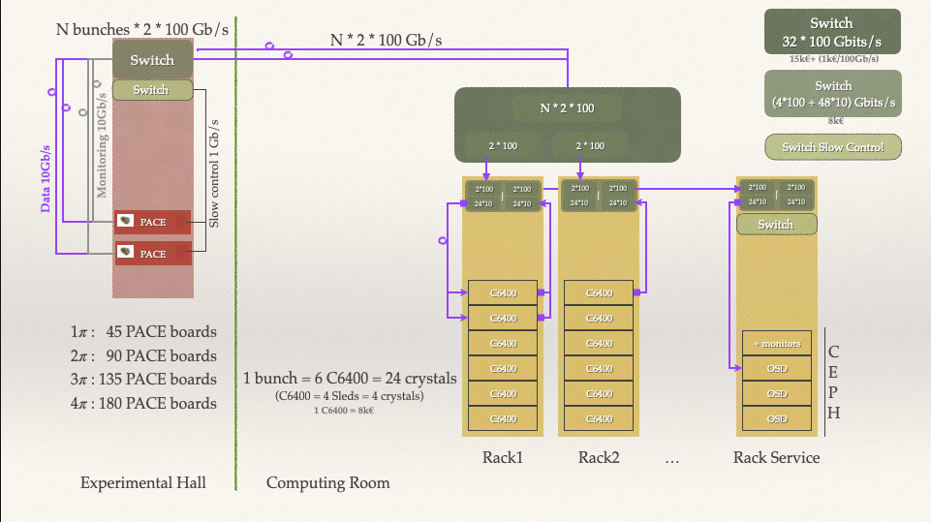Figure 7: DAQ box architecture for phase 2 integration
In the experimental hall, optical fibers out of the STARE board are connected to Top Of the Rack switches (4*100 Gbits/s + 48*10 Gbits/s).

Crystals can be grouped by bunches. Two scenarios can be covered :

- Assuming a maximum of 7.5 Gbits/s (upper limit tested so far between STARE and node) bandwidth is needed per board, a bunch could be composed of 24 STARE [Crystals] which requires then a 180Gbits/s link fitting with some margin into 2*100Gbits/s links.

- Assuming a less stringent limit of 3.2 Gbits/s (upper required for 50 kHz and events not grater that 8192 bytes long) bandwidth needed per board, a bunch could be composed of 48 STARE [Crystals] which requires then a 154 Gbits/s link fitting with some margin into 2*100Gbits/s links.

With the additional margins in both cases, one can also absorb the data for the monitoring if the inspection is performed sparsely i.e. one crystal/signal from time to time.

Through optical fibers, the 2 links per bunch of STARE transport the data to the computer room. One possibility is to go first through a full 100Gbits/s switch (32 channels) in charge of re-distributing data to different C6400 racks : this stage is not mandatory at long as the number of connections is not too high to be manageable but should simplify the maintenance and evolution. The racks in the computer room could be arranged differently depending on the two proposed scenarios.
- Two 100Gbits/s links arrive in one (4*100 Gbits/s + 48*10 Gbits/s) switch on the top of one rack. 24*10Gbits/s links feed six C600 computers (4 sleds in one C6400 machine) with input data. Their outputs could be re-directed, if written to disks, to the rack of services which includes the CEPH disk array. For that the transfer is done through the second half of the top switch connected through 100Gbits/s links to a switch in the rack of services. Such a scenario is displayed in Figure 4. Additional C6400 racks could be added as soon as the sum of total used channel is less that 32.
- Two 100Gbits/s links arrive in one (4*100 Gbits/s + 48*10 Gbits/s) switch on the top of one rack. 48*10Gbits/s links feed 12 C600 computers (4 sleds in one C6400 machine) with input data. An additional (4*100 Gbits/s + 48*10 Gbits/s) switch is required to transfer data to the rack of services. Additional C6400 racks could be added as soon as the sum of total used channel is less that 32.

Current prices (end of 2021) are given in the Figure 4 to allow an estimation of a raft cost of the installation.

DAQ box : software architecture
Memory Consumer
The SQM process push UDP data into memory buffers. In order to not overfill the memory and loose events, an appropriate process should be developed, able to empty the memory faster that the SQM is able to fill it. Different solutions can be considered for the memory pull (FIFO/circular buffer). Whatever the choice, real time monitoring should be performed to check for any lost of data and/or to check the memory is not overloaded. Appropriate actions (automatic and/or by human) should be set up to deal with such critical situation.
Here is a non exhaustive roadmap for the Memory Consumer developments.
- Tests with One Queue
  - Memory consumption + some shaping of the data before sending to /dev/null
    - Re build of the ADF Frame required ?
    - Use of the compressed data format possible ?
    - Performances
  - Data sent again in a consumer dumping ADF Frames in files
    - Check data integrity (adf out of the pipeline = adf injected in the pipeline)
    - Performances (including CEPH ?)
  - Monitoring
    - alerts in case of problems with memory buffer
    - actions at the Slow Control level and/or Run Control level ?
- Tests with Many queues
  - Memory consumption
    - Performances
  - Monitoring
    - alerts in case of problems with memory buffer
    - actions at the Slow Control level and/or Run Control level ?
  - Stress of the system
    - add delay in one line / asymmetric counting rates / emulate dead channels etc ..

Topology Manager
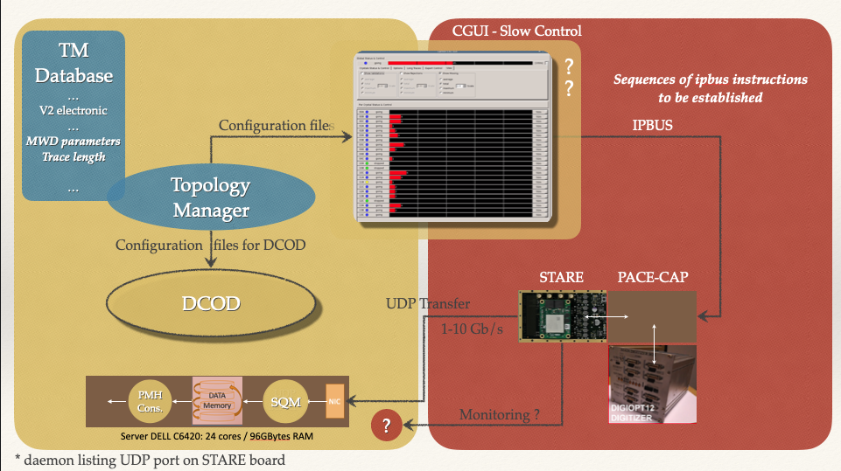Figure 8: Topology Manager, Slow control and phase 2 electronics
To run online processings, one has to be sure all the subsystems from the electronic boards up to the storage array are set up consistently. The goal of the Topology Manager (TM) is to help for that by :
- providing a description of the various electronic boards to be attached to the DAQ box
- providing the full graph of all the running subsystems
- providing a UI to manage the full tree structure of the whole system
- providing all the configurations files required to set up each active board
- ensuring these electronics configuration files are copied at the right place
- providing all the files required by DCOD to set up the workflow able to process the data
Depending on the local acquisition, the TM may (most of the cases) or not be in charge of dealing directly with the ancillaries. For the very beginning of the phase 2 at LNL, regarding the ancillaries, except for the GTS tree, the ancillaries are to be managed by the local xDAQ, the connection with AGATA being ensure by TCP links (DCOD producer receiving ADF formatted data from xDAQ) the standard way to exchange data between two different DAQ systems.
Regarding the GTS Tree, is has been decided to modify the slow control protocol from EPICS to IPBUS. This has thus trigger a upgrade of the TM. The TM should also integrate the new electronic boards of the phase 2 electronics.
Here is a non exhaustive roadmap for TM developments.

- LNL ancillaries
  - Code review and cleaning
    - New developer in charge of the package : it requires time to master the product
    - Phase 0 electronics deprecated : to be set as such
  - Modification to handle GTS Tree with IPbus slow control ONGOING
    - Note : leaves and FIFO fully IPbus, IPBus to EPICS foreseen for the root node
  - Other boards likely to be used are already in TM: DIGIOPT12, GGP, GTSS, AGAVA ...
- AGATA phase 2 electronics
  - add new boards (CAP,STARE ..) in TM
  - add generation of the configuration files PENDING waiting for production version of v2
- AGATA Phase 2 Data Management Plan
  - Since it contains a full description of the various electronics and the way they are linked
    - TM could/should be used to archive appropriate meta-data
    - see also Chapter 2
  - TM as a tool to generate any AGATA workflows – Online and offline
    - more advanced / user friendly User Interfaces
    - formats to exchange the workflow from online to offline
      - see for instance https://www.commonwl.org/user_guide/

Slow Control
Notes from the first joined meeting FEE/DataProcessing dedicated to slow control [07/12/2021]

In AGATA, GEC has been developed to deal mainly with phase 0 electronics because it is complex (several entry points)
→ it should not been required in a system with only phase 2 electronics (even GGP)
In principle the global v2 AGATA electronic could be managed then with a single user interface such as the CGUI (to be confirmed).
In case the configuration of the v2 card is too complex (requiring complex scripts), a intermediate service (feed by the files provides by the TM) should be set up and this requires some time to be developed. An answer on that question should be known by the beginning of 2022.
The MWD parameters have almost not been modified during on the last campaign. It is based on long traces being recorded and processed offline.

Various questions, important points raised :
- Python version to be clarified (CGUI, IPbus related, etc …)
- The crystal id should be managed properly. Either as a parameter delivered to the IPbus server or through the UDP server
- The MWD requires parameters. They should be coming from the TM. Lengths of traces and threshold should not be forgotten
- In principle already at the STARE level, traces should be delivered using the ADF format. A slight modification might still be performed in SQM if required. In case more complex processing is required, the dedicated actor in charge of consuming the memory buffer can be used at the cost of the processing time
- How to monitor (scope mode) ?

Actions :
A.G. to establish lists of ipbus instructions for standard slow control actions
E.L. to check the current version of the current cgui

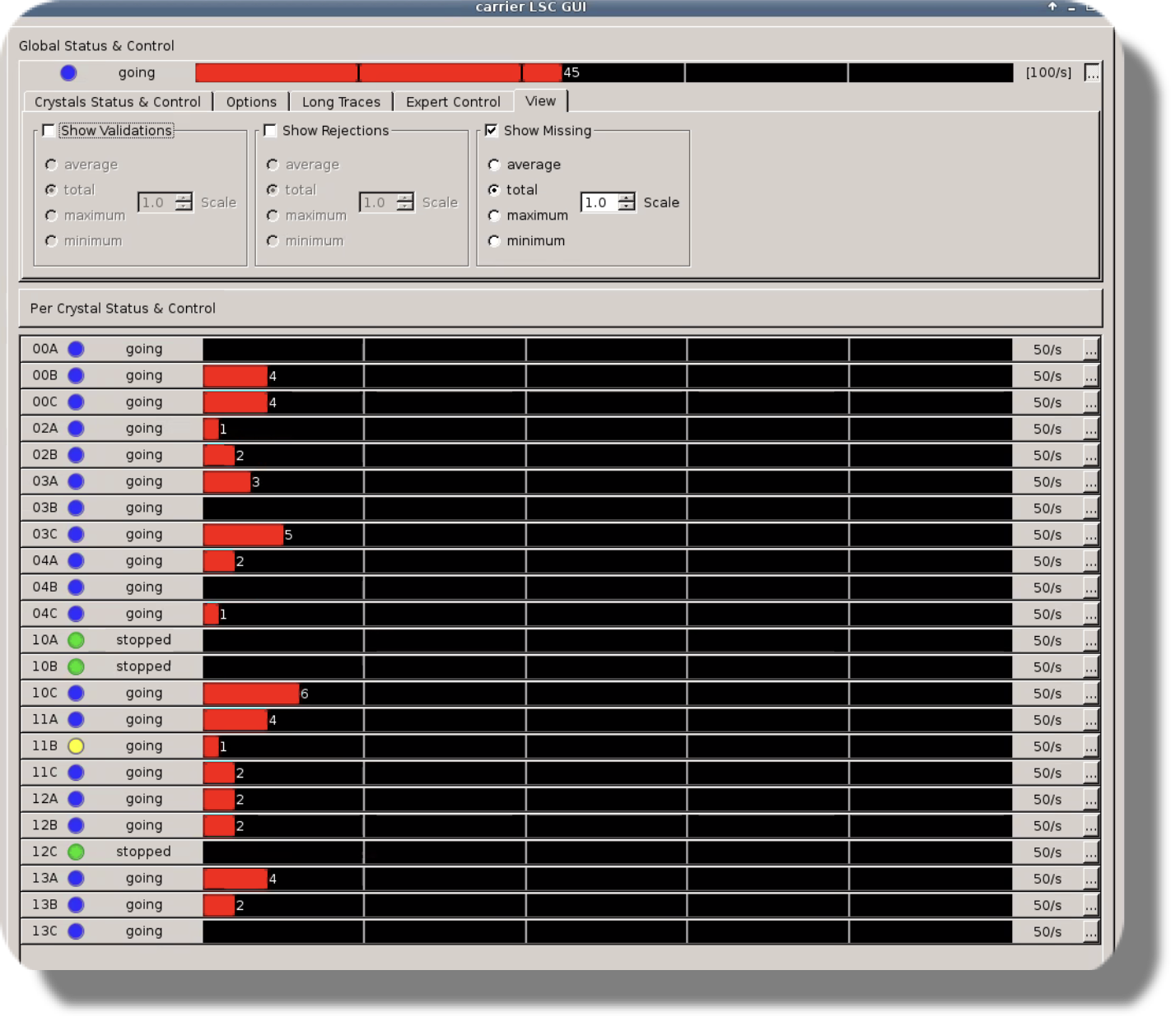Figure 9: Snapshot of the Phase 0-1 SlowControl CGUI

Here is a non exhaustive roadmap for Slow Control developments.
- CGUI Phase 1
  - CGUI Code review ONGOING
    - Python version to be clarified at each levels CGUI / IPBus etc ..
  - ...
- CGUI Phase 2
  - V2 electronic requirements
    - Could v2 be managed by a single user interface ?
    - List of IPBus instructions for standard slow control actions to be provided by FEE
    - If v2 too complex, intermediate service might be needed … would require dev. time
    - Many new parameters to be managed (at the TM level) such as
      - The traces lengths / thresholds
      - MWD parameters
      - the crystal ID either as a parameter to the IPBus server or through the UDP server
      - ...
  - New CGUI
    - Definition
    - How to include monitoring in the system (scope mode) ?
    - Connexion with SQM and Run control in case of UDP packets losses and memory issues

Period 2026-30 : phase 2 electronic + GSI ancillaries
With all the AGATA New Electronics Boards (NEB) based on ethernet readout, there is no more point-to-point connections. Since previous readout electronics [GGP] are to be removed from the array, the rule one node/crystal is not necessary anymore and then different approaches can be implemented so that the CPU-load can be distributed over High Performance Computer farms (HPC).
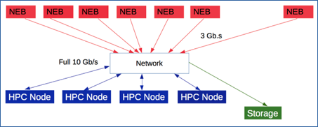Figure 10: HPC Mode for the DAQ
On the pure AGATA side, within such a scheme, one can probably get rid off hard trigger and run at full speed regarding the data transfer at the local level. Such approach however would require to have a efficient and fast SOFT trigger to reduce the amount of data fully processed (PSA/Tracking) and stored. Of course such acquisition has to remain compatible with the various ancillaries to be used during the different campaigns.

A Phase2 electronic integration in the DAQ box

DAQ box : hardware architecture
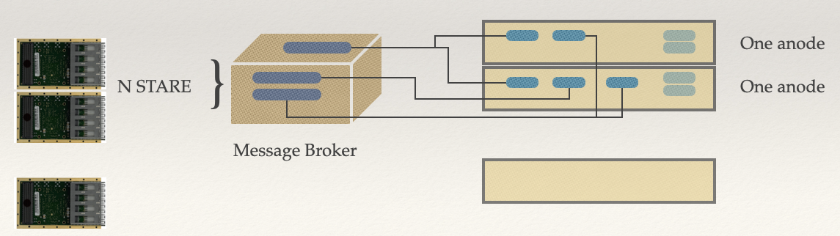Figure 11: Phase 2 electronic, Message Broker and 'a la demande' processing

With only phase 2 electronic for AGATA, one can imagine to have few machines, each receiving the data stream out of several (N) STARE boards. Such frontend machines would have large memory and high speed network interfaces 40 Gb/s or even up to 100Gb/s. Several HPC nodes then could consume the data streams as show in Figure 11 with processes that can be raised ‘à la demande’ depending on the data rates.
Here is a very basic and preliminary roadmap for such developments.
- Requirements for the front end machines
  - Data transfer tests under UDP/RUDP
  - Crude estimation of number of machine per STARE, characteristics (memory, network interface, CPU, etc)
  - ...
- Requirements for the HPC nodes.
  - ...

DAQ box : software architecture
Within such architecture (Figure 11), data streams are built into memory and should be consumed quickly to limit any saturation of the physical memory limit. To avoid any complex constructions of data pipelines, a publish-subscribe pattern is likely to be used: SQM processes sent their data into a message broker and the data consumers are raised depending on the pressure. One possibility also for the consumers would be to rely on containers, such as docker or singularity, in order to be able to run more that one local level data pipeline per machine.
Of course, this should be also built taking into account the global level which could become a bootle neck. As well to optimize the use of the resources, it would be better to have an efficient and fast soft trigger able to decide whether or not a given raw event is likely to be interesting or not (see chapter Advanced data pipelines and workflows)

Here is a very basic and preliminary roadmap for such developments.
- Message broker
  - Determinations of the specifications
  - Choice of the message broker (Redis, RabbitQM, Kafka etc ...)
    - stress tests using the STARE emulator
  - Integration in the system : Topology Manager, Slow Control, DCOD etc ...
- Data Consumers
  - In container construction ? DCOD integration ?
  - Automatic control to raise new ones in case of data pressure to high

Chapter 2 - Data Management
To be written. Key words are :
Data and Meta-Data Management Plan → Open Science
Databases
…

Chapter 3 - Advanced data pipelines and workflows
To be written. Key words are :
Load balancing
Soft Trigger
Algorithms optimizations
GPU Integration
Machine Learning
Reprocessing (on clusters, clouds)
Monitoring : containers, time series databases, Grafana, elastic search
…

Chapter 4 – Data Analysis & Re Processing

To be written. Key words are :
Machine Learning
Jupyter Notebook
Monitoring
Advanced methods : hypercubes, imaging etc …
...

Adaptative Grid Search
Orsay Forward Tracking
It might be required to send longer traces (more that 100 samples) in case the MWD algorithm could not be performed inside the FPGA in the PACE board.
It has been tested with three links sending data in parallel on emulated data
Others are One-bit sliding window protocol and Go back N protocol

